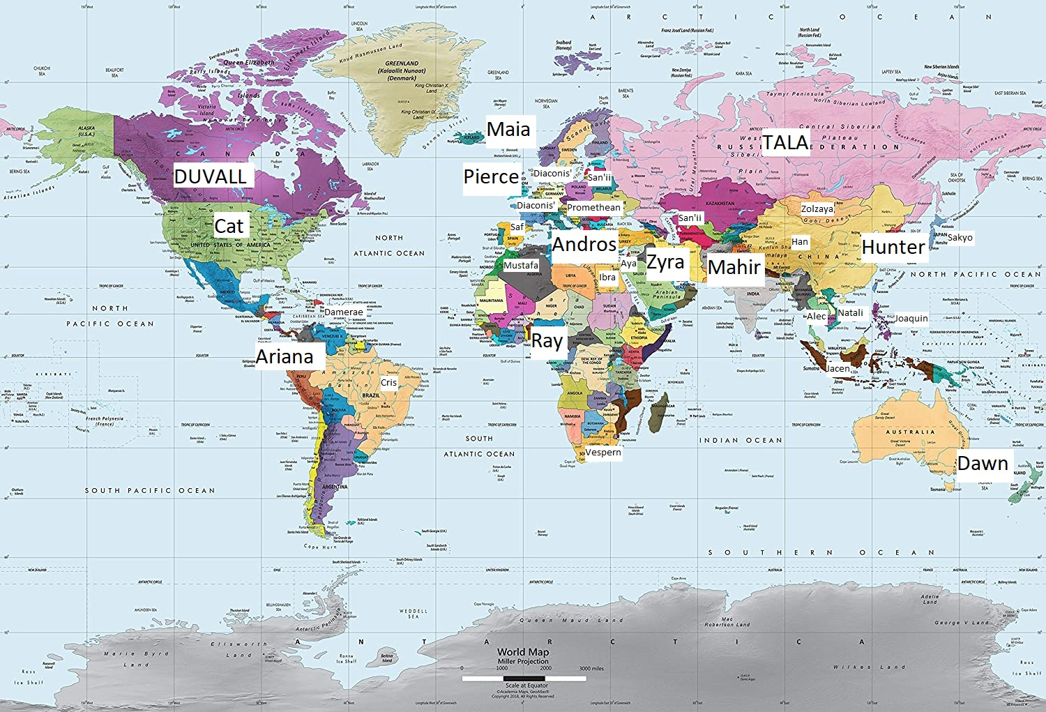



Europe:

England
- Devin Pierce
- Diana Pierce

Wales
- Zach (Gwalch) Helcan

Scotland
- Lara McLean

Ireland
- Charlotte Byrne

France
- Julien Saint-Clair (Charles-Magnus Diaconis)

Sweden
- Elesa Hellstrom (Teresa Diaconis)

Netherlands
- Demetrius Van Thyra (Ozymandias Diaconis)
- Giselle Erkaya
- Jessica Erkaya

Belgium
- Willemijn de Witte

Liechtenstein/Luxembourg
- Hilde Gartnerin

Switzerland
- Rogier Durand

Spain
- Saf (Santiago Salazar)
- JJ (Romani person)

Andorra/Catalonia
- Ignasi Izaguirre
- Malagán Boc de la Morera

Portugal
- Nora Dos Santos

Norway
- Pernelle Stokke

Denmark
- Hans (Hansel Qyser)
  - Janus Qyser
  - Holger Qyser

Sami
- Hallbjorn Stenberg

Finland
- Harald Räikkönen

Greenland/Arctic
- Uluusiit

Iceland
- Maia Ragnardottir
- Ragnar Sylwasen

Germany
- Brooklyn Sawyer (Säger)

Italy
- Augustus Shields (Not demortal, more Roman than Italian)
- Thaddeus Di Valtares (Not demortal)

Vatican City
- Saint Maria Turpin

Czechia
- Alois Novotny

Poland
- Kasia (Katarzyna Pietrzak)

Austria
- Oliver Albrecht

Hungary
- Matthias Constantin

Romania
- Tatjanna Murastisa

Bulgaria
- Ronan Jyklinaan

Serbia
- Jelena Miladinovic

Greece
- Andros Kairis (half)
- Dimaros Kairis

Latvia
- Myroslav Gulbis

Ukraine
- Olha Taimanova

Russia
- Tala (Vitaly Saranov)
- Leon (Lyonechka Saranov)
- Anastasya
  - Andros Kairis (half)

Asia:

Iran:
- Zyra (Shazyra Shayesteh)
- Soraya Shayesteh

Iraq/Kurdish:
- Ardalan

Jordan/Palestine:
- Zuhayr Barghouti (Solomon Diaconis)
- Janna Barghouti
- Aya (Ayinari)

Saudi Arabia:
- Anwar Qadir

Syria:
- Iqra Alzuhur

UAE/Oman/Yemen:
- Hassan

Israel:
- Alysar Margolis (Hypatia Diaconis)

North Korea:
- Seung Hwahn

South Korea:
- Kwon Taehyun (Hunter Sr.)
- Jung Ahrin (Irene)
- Kwon Taekyeon (Hunter)
- Kwon Taerin (Julia)

Japan:
- Hiwatari Sakyo
- Hiwatari Sakura

China:
- Li Han
- Li Wang

Hong Kong:
- Yanjun Lee (Not demortal)
- Mei Lee (Not demortal)

Taiwan:
- Cai Lihua (Cora)
- Cai Zhukan (Damian)

Thailand:
- Jirayu Chaisongkhram (Alec Song)

Vietnam:
- Lương Nhàn Nhã (Natalie Luong)
- Sophie Lương
- Nate Lương

Philippines:
- Zolzayagiin Joaquin
- Makisig Dalisay

Mongolia:
- Khutuluny Zolzaya

Malaysia/Indonesia/Cambodia:
- Kosal Abhyasaputra (Jacen Abhyasaputra)
- Lestari Indahputri
- Abhyasa
- Indah

Pakistan/Afghanistan:
- Mahir Shahzad
- Ahmar Shah (not demortal)
- Ensa Shahzad (not demortal)

India:
- Sunehri Vorana
- Suhana Vorana (not demortal)
- Gurjas Veer Talvar - Punjabi
- Varrsha Aciriyar Subramaniam - Tamil

Sri Lanka:
- Ranuga

Bangladesh/Tibet/Myanmar:
- Lalsantali/Lalsangzuali - Mizo/Bangladesh/Tibet/Myanmar

Bhutan:
- Tshering Dorji - Bhutan

Turkey:
- Gülizar Erkaya

Armenia:
- Tigran Khachaturian Hart (not demortal)

Kazakhstan:
- Lyazzat Khambetova

Kyrgyzstan:
- Ruslan Yurtaev

Africa:

Egypt:
- Ibrahim Al-Sirri (not demortal)

Nigeria:
- Ray Masquerade

Algeria/Tunisia:
- Mustafa Barbaros

Morocco/Guinea/Ivory Coast/Sierra Leone/Senegal:
- Girard Bassari-Sherifian

Kenya/Tanzania/Uganda:
- Fahari

Ethiopia:
- Ewnetu

Sudan/Chad/Central Africa:
- Yalwa

Malawi:
- Nkosi

Eswatini/Swaziland:
- Kelile

South Africa:
- Count Vespern

Americas:

Canada (Quebec):
- Lianne Duvall
- Eve Duvall (Evereal Deveaux)
- Madelaine Duvall

Native American:
- Eska (Eskaminzim Hart) Thorne (not demortal)
  - Wemilat Thorne (not demortal)
- Eyan (Eyanosa) Hart (not demortal)

New American:
- (Huckleberry?) Yankee Kidd
- Big Mama Delilah
- Sheila
- Susanna Summer

Mayan (Mexico):
- Cualli
- Horado

Jamaica:
- Damerae Waters

Aruba/Curacao:
- Rychacviana

Brazil:
- Cris (Cristiano Zaragoza)

Quechua:
- Pawlu Ryder

Latin/Ecuador/Argentina:
- Ariana Corzales
- Mera (Esmeralda Corzales)

Oceania/Polynesia:

New Zealand/Maori:
- Dawn Awheana
- Katie Awheana

Papua New Guinea:
- Nori-Loa Jaukae

Australia (Aborigine):
- Kirra Waratah

Samoa:
- Iakopo

Tahiti:
- Nuihau

Plots:
Devin - England
Aya - Palestine
Diana - England
Jasper -
Archer -
Dawn - New Zealand/Maori
Iakopo - Samoa
Nuihau - Tahitian
Kirra Waratah - Aborigine
Nori-Loa Jaukae - Papua New Guinea
Hunter - South Korea
Alec - Thailand
Natalie - Vietnam
Cora - Taiwan
Jacen - Indonesia/Cambodia/Malaysia?
Lestari
Sakyo - Japan
Sakura
Joaquin - Philippines
Han - China
Julia
Seung Hwahn - North Korea
Cat - Native American/Regular American (Native Khyto drowned out by Order)
Brooklyn Sawyer - Germany
(Huckleberry?) Yankee Kidd - Yankee/New York Italian Gangster
Susanna Summer - Southern Belle
Big Mama Delilah - New Orleans (barkeep, calls everyone ‘baby’?)
Ariana - Latin Spanish
Saf - Spain (Andalusian?)
Cris - Brazil
Nora - Portugal
Pawlu - Quechua
Cualli - Mayan (Tzeltal)
Horado - Mayan (Tzotzil)
Andros - Greek
Ibrahim - Egypt
Zach (Gwalch) - Wales
JJ - Romani
Anton - England
Lara McLean - Scotland
Charlotte Byrne - Ireland
Tala - Russia
Myroslav Gulbis - Latvia
Javokhir - Uzbek
Khutuluny Zolzaya - Mongolia
Lyazzat Khambetova - Kazakh (Zhansaya _betova?)
Ruslan Yurtaev - Kyrgyzstan
Grishashvili - Georgia?
Tajik?
Turkmenistan?
Lithuania?
Belarus?
Svetlana - Ukraine?
Ray - Nigeria (Yoruba)
Damerae Waters - Caribbean/Jamaica (Patois)
Fahari - Swahili
Nkosi - Xhosa
Kelile - Zulu
Rychacviana - Papiamentu (Papiamento)
Ewnetu - Amharic (Ethiopia)
Yalwa - Hausa
Mustafa - Berber (Algeria/Tunisia)
Count Vespern - Afrikaans (South Africa)
Zyra - Iran/Palestine
Soraya - Iran
Giselle - Turkey
Hansel Qyser - Denmark
Hassan - UAE/Oman/Yemen
Maia - Iceland
Pernelle - Norway
Harald Räikkönen - Finland
Hallbjorn Stenberg - Sami
Uluusiit - Greenland/Arctic
Estonia?
Mahir - Pakistan/North India
Ahmar Haider Shah - Urdu (Pakistan/Afghanistan)
Sunehri Vorana - Hindi (North India/Nepal)
Gurjas Veer Talvar - Punjabi
Varrsha Aciriyar Subramaniam - Tamil
Ranuga - Sinhala (Sri Lanka)
Lalsantali/Lalsangzuali - Mizo/Bangladesh/Tibet/Myanmar
Tshering Dorji - Bhutan

Eve - Canada
Lianne - Canada/Quebec

Atlas
Hypatia - Hebrew/Israel
Charles-Magnus - France
Oliver Albrecht - Austria
Rogier Durand - Switzerland
Willemijn de Witte - Belgium
Holger Qyser - Denmark
Iqra Alzuhur - Syria
Ignasi Izaguirre - Andorra/Catalonia
Girard Bassari-Sherifian - Morocco
Saint Maria Turpin - Vatican
Hilde Gärtnerin - Liechtenstein/Luxembourg
Alois Novotný - Czech
Solomon - Palestine/Jordan/Iraq/Saudi/UAE
Janna Barghouti - Palestine/Jordan
Anwar Qadir - Saudi
Ozymandias - Netherlands
Gulizar Erkaya - Turkey
Tigran Khachaturian - Armenia
Teresa - Swedish
Brandin
Gale Hautdesert

Ronan Jyklinaan - Bulgaria
Matthias Constantin - Hungary
Tatjanna Murastisa - Romania
Kasia (Katarzyna Pietrzak) - Poland
Jelena Miladinovic - Serbia
Slovak?
Olha Taimanova - Ukrainian
Myroslav Gulbis - Latvian

Character List:
Devin Pierce
Feodora Pierce (Granny)
Jasmine Shields
Bliees Catohr
Tracy Harper
Jack Terapier
Hayley Terapier
Sam Terapier
Aya (Ayinari)

Diana Pierce
Jasper
Vars Kenan
Archer Jackson
Shauna
San (Hassan)

Hunter Kwon (Taekyeon)
Julia Kwon (Taerin)
Alec (Jirayu Chaisongkhram)
Natalie (Nhan Nha) Luong
Sophie (Thi Le) Luong
Nate Luong
Sakyo Hiwatari
Ballerina
Admiral Hiwatari
Sakura Hiwatari
Cora Cai (Lihua)
Helena Cai
Cameron Cai (Yifan)
Jacen (Kosal) Abhyasaputra
Lestari Indahputri
Abhyasa
Indah
Seung Hwahn
Zolzayagiin Joaquin
Makisig Dalisay
Irene Jung (Ahrin)
Li Han
Malagán Boc de la Morera
Cai Xhukan?
Gale Hautdesert
Javokhir
Xomagog
Brandin?

Cat (Serena Thorne)
Brooklyn Sawyer
(Huckleberry) Yankee Kidd
Big Mama Delilah
Janus Qyser
Mara Oppenheimer (Doc)
Wemilat Thorne
Jennifer Thorne
Amadeus Di Valtares
Milos Di Valtares - nephew, by Carmen Di Valtares (Joffrey Type)
Carmen Di Valtares - sister, Cersei type
Andreas Di Valtares - brother
Thaddeus Di Valtares - grandfather
Ignatius Di Valtares - father (Tywin type)
Lucas Shields
Augustus Shields - ancestor (went a little crazy)
Mr. Shields - father (Richest guy in the galaxy)
Joseph Shields - oldest brother
Carter Shields - middle brother
Jasmine Shields - older sister
Paris Hart - acquaintance
Genevieve Hart - stepmother
Mei Lee - acquaintance
Yanjun Lee - father
Josephine Bose - acquaintance, Blair Waldorf
Igor Swords
Deucalion Swords
Trina Swords
Ivan Swords
Venus Swords
Violet Swords

Ariana Corzales
Esmeralda (Mera) Corzales
Cris Zaragoza
Saf Salazar
Pawlu Ryder
Nora Dos Santos
Stella/Estella
Cualli
Horado
Janine
Zoe Clark

Andros Kairis
Anton Jasalca
Zach (Gwalch) Helcan
JJ
Ibrahim Al-Sirri
Qiu
Charlotte Byrne
Lara McLean
Yvonne

Tala Saranov
Leon Saranov
Khutuluny Zolzaya
Ruslan Yurtaev
Lyazzat Khambetova
Anatoly (Tolya) Saranov

Ray Masquerade
Damerae Waters
Sheila
Fahari
Mustafa Barbaros
Nkosi
Kelile
Rychacviana
Ewnetu
Yalwa
Count Vespern
Iyara Onyemaechi

Dawn Awheana
Ra’Qar
Chase Armstrong
Finn Rodriguez
Vanessa Castle
Logan Tyranus
Nuihau
Kirra Warratah
Nori-Loa Jaukae
Iakopo
Jacinda Carson
Rongo Awheana
Katie Awheana
Zeus (Katie’s cat?)
Giselle Erkaya
Hansel Qyser

Zyra Shayesteh

Maia Ragnardottir
Ragnar Sylwasen
Johanna
Pernelle Stokke
Harald Räikkönen
Hallbjorn Stenberg
Uluusiit
Uthyr Kwon (Taehyun)

Mahir Shahzad
Ahmar Haider Shah
Shahanshah
Sunehri Vorana
Ensa Shahzad
Suhana Vorana
Gurjas Veer Talvar
Varrsha Aciriyar Subramaniam
Ranuga
Lalsantali/Lalsangzuali
Tshering Dorji

Eve Duvall (Diaconis)

Atlas Diaconis
Charles-Magnus Diaconis
Hypatia Diaconis
Solomon Diaconis
Ozymandias Diaconis
Teresa Diaconis
Lianne Duvall
Gulizar Erkaya
Soraya Shayesteh
Tigran Khachaturian
Eyanosa Hart
Eskaminzim Hart
Augustus Shields
Thaddeus Di Valtares
ARS Goliath
ARS Notoria
Ywain Gorrurien

Rogier Durand
Oliver Albrecht
Willemijn de Witte
Holger Qyser
Girard Bassari-Sherafian
Saint Maria Turpin
Iqra Alzuhur
Ignasi Izaguirre
Renaud
Hilde Gartnerin
Alois Novotny

Ronan Jyklinaan
Matthias Constantin
Kasia Pietrzak
Jelena Miladinovic
Tatjanna Murastisa
Myroslav Gulbis
Olha Taimanova

Zero (Ashukhai)
Echo (Dilnaza)
Dimaros Kairis
Anastasya Kairis
Alexander
Astra
Li Wang
Ka’Li
Alysar Margolis
Julien Saint-Clair
Zuhayr Barghouti
Demetrius Van Dijkstra
Elesa Hellstrom
Janna Barghouti
Zakia Barghouti
Petra
Henri Saint-Clair

